DAY 6 – REPORTS, DASHBOARDS & BDD
Xray Reports: Execution report, coverage report, traceability report
Dashboards: Xray gadgets, Jira filters, saved JQL, dashboard sharing
Quality Metrics: Pass %, fail rate, defect leakage, test effectiveness
BDD with Xray: BDD overview, Gherkin syntax, Feature, Scenario, Given-When-Then

Xray Reports : Execution report, coverage report, traceability report ::
Reporting is a critical activity in test management because it provides visibility into the quality of the product and the effectiveness of the testing process. Xray offers powerful reporting capabilities that help teams track progress, identify risks, and communicate test status to stakeholders.
Types of Xray Reports :
Xray provides several built-in reports designed to address common quality management needs.
Test Execution Report :
Displays the execution status of tests within a Test Execution or Test Plan. It shows:
- Total number of tests
- Passed, failed, and blocked tests
- Execution progress
This report helps teams monitor testing completion and readiness.
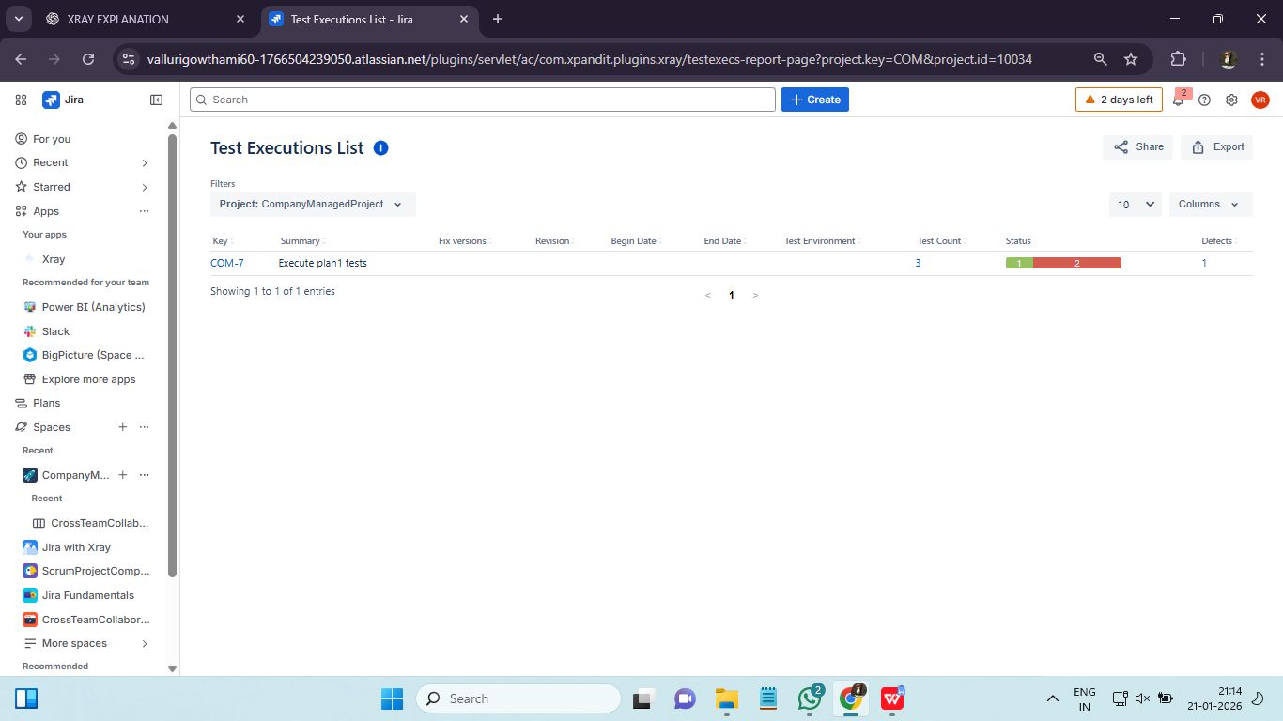
Test Coverage Report :
The Test Coverage Report shows the relationship between requirements and test cases.
Key Insights:
- Which requirements are covered by tests
- Execution status of linked tests
- Untested or partially tested requirements
Coverage reports help teams identify gaps and reduce risk.
Traceability Report :
Traceability reports provide end-to-end visibility from requirements to defects.
Benefits:
- Ensures complete validation
- Supports compliance and audits
- Improves accountability
Traceability reports are especially valuable in enterprise environments.

Dashboards: Xray gadgets, Jira filters, saved JQL, dashboard sharing ::
Dashboards provide a consolidated view of project status. Xray integrates seamlessly with Jira dashboards, allowing teams to visualize quality metrics using gadgets.
Common Xray Gadgets:
- Test Execution Status
- Test Coverage
- Defect Distribution
- Progress Tracking
Dashboards enable stakeholders to quickly understand project health.
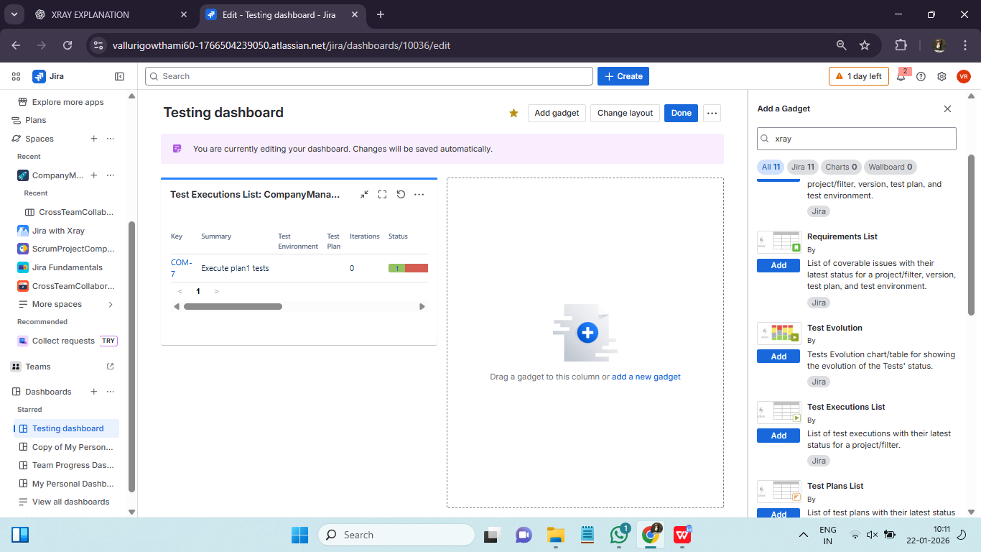
Using Jira Filters and JQL :
Jira Query Language (JQL) allows users to create powerful filters for reporting.
Common Use Cases:
- Identify failed tests
- Track unexecuted tests
- Monitor defects linked to tests
Saved JQL filters can be reused in dashboards and shared across teams.
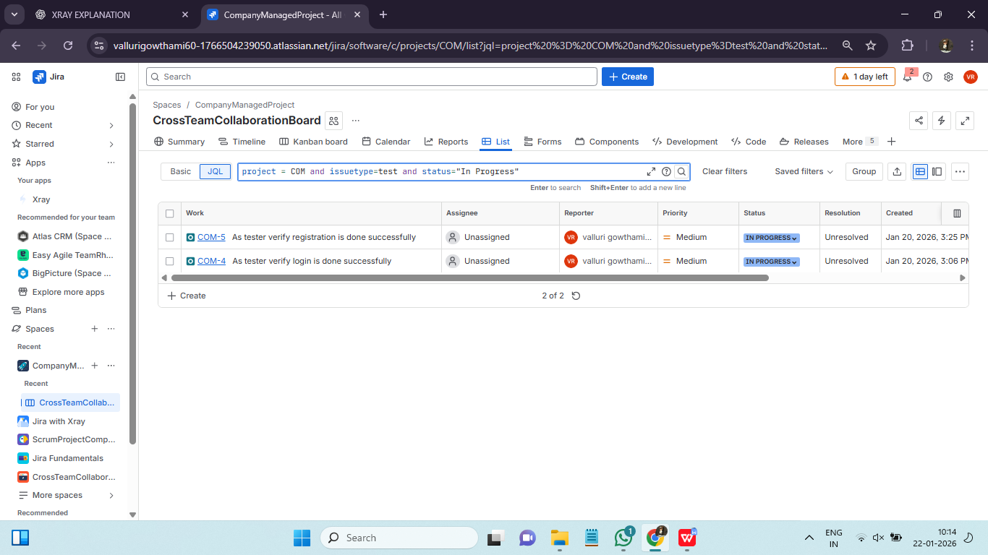
Sharing Dashboards and Reports :
Dashboards and reports can be shared with:
- Project teams
- Management
- External stakeholders
Controlled sharing ensures the right level of visibility without compromising security.
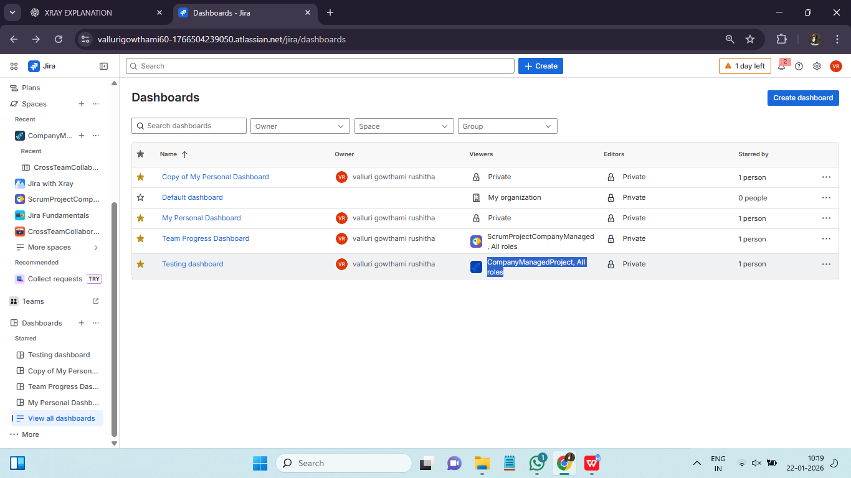

Quality Metrics: Pass %, fail rate, defect leakage, test effectiveness ::
Quality metrics help teams evaluate testing effectiveness.
Common Metrics:
- Pass percentage
- Failure rate
- Defect leakage
- Test effectiveness
Pass % :
Pass % shows: Percentage of executed tests that passed successfully.

Formula :
Pass % = (Passed Tests / Executed Tests) × 100

Pass % | Interpretation
95–100% | Release-ready
80–95% | Acceptable with risk
<80% | High risk

Fail rate :
Fail Rate shows: Percentage of executed tests that failed.

Formula :
Fail Rate = (Failed Tests / Executed Tests) × 100

Defect leakage :
Defect Leakage means: Defects that escaped testing and were found after release (UAT/Production).

Formula :
Defect Leakage % = (Post-release defects / Total defects) × 100

Test effectiveness :
Test Effectiveness measures: How well test cases identify defects before release.

Formula :
Test Effectiveness = (Defects found in testing / Total defects found) × 100

BDD with Xray: BDD overview, Gherkin syntax, Feature, Scenario, Given-When-Then::
Behaviour Driven Development (BDD) is a testing approach that emphasizes collaboration between business, development, and QA teams.
BDD focuses on describing system behaviour in a human-readable format using scenarios.
BDD with Xray
Xray provides native support for BDD by allowing tests to be written using Gherkin syntax.
Core Gherkin Keywords:
- Feature
- Scenario
- Given
- When
- Then
BDD tests improve communication and shared understanding.
Creating BDD Tests in Xray :
BDD tests in Xray are created as Test issues with type set to BDD.
Steps:
- Define Feature and Scenarios
- Write Given-When-Then steps
- Link to requirements
BDD tests can be executed manually or automated.
